ETL🡪Airbnb Edition

Mercy Muigai and Sana El-Bakry

* We started off loading in our csv files we downloaded from Kaggle:
* One was filled with information regarding each property in Seattle, WA, which gave us ~ 60,000 rows and 92 columns:

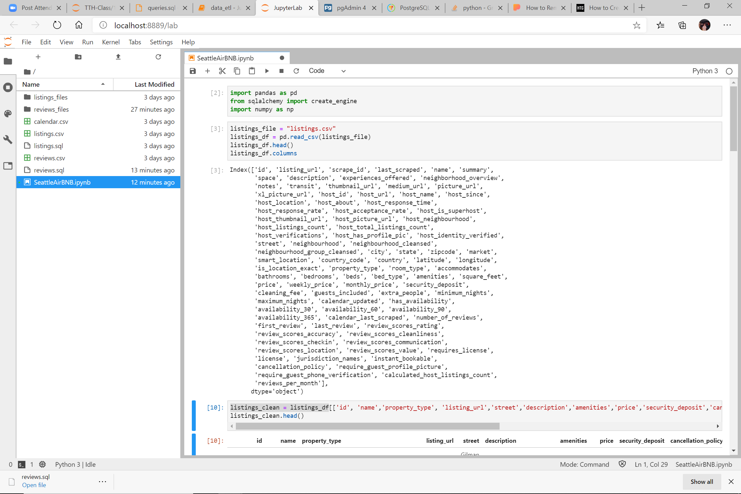

* The other was smaller with only 6 columns and ~80,000 rows. This csv included the date the reviews of a specific property was given:

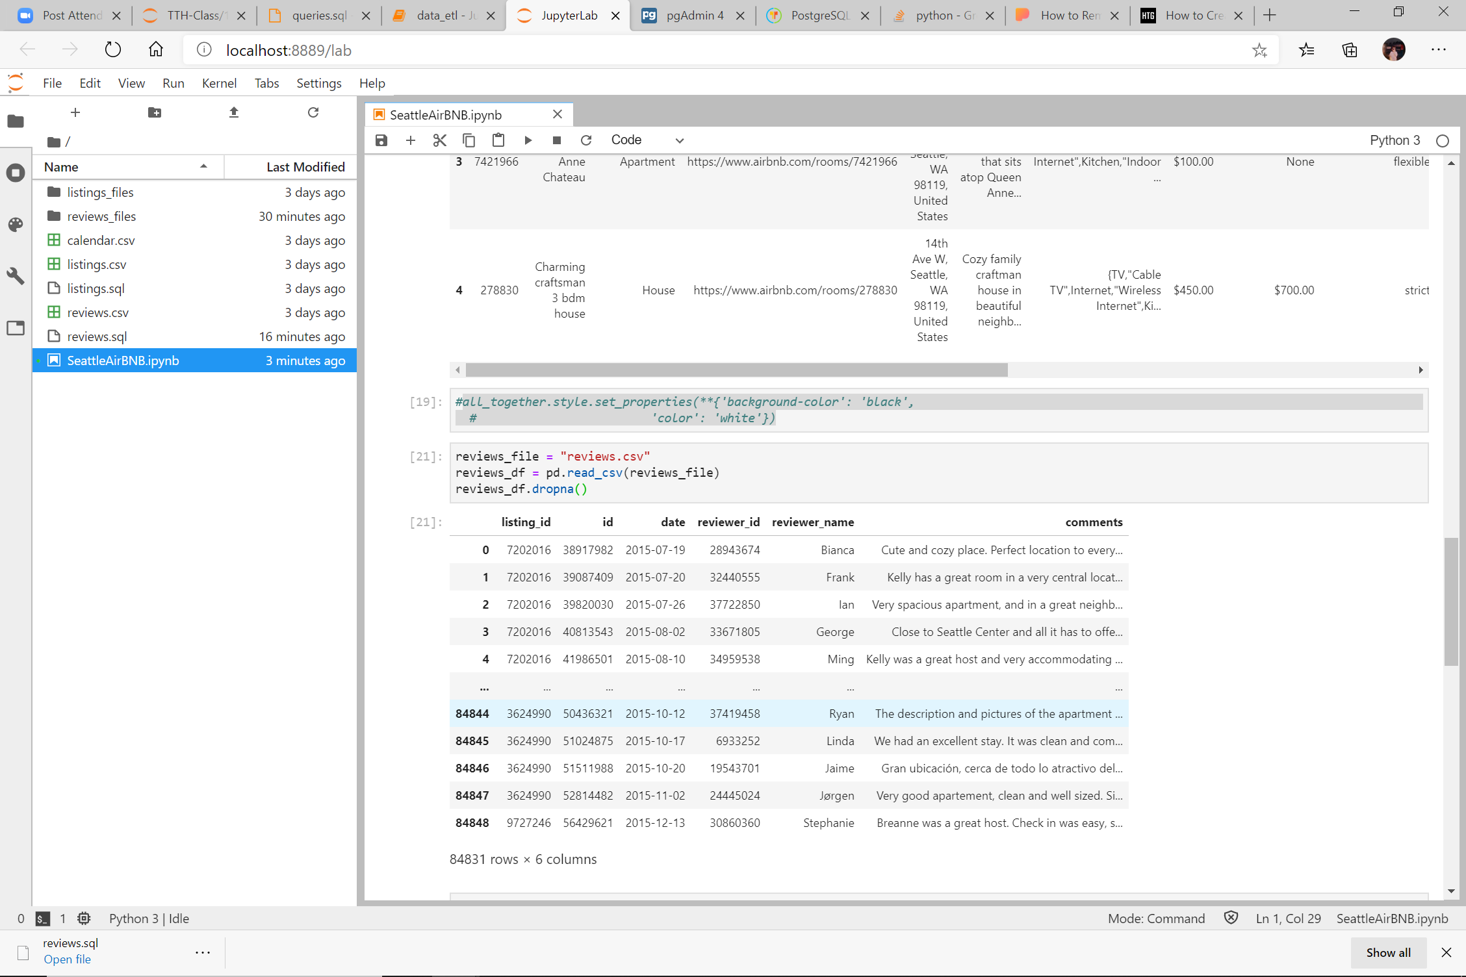

* We cleaned up the tables taking the first one down to 16 columns and the second down to three, grabbing only the columns we thought were essential for booking an Airbnb.
* We created the tables in Postgres, created our connections to the tables we created, loaded our information into the tables.
  + Results for BOOKING info: We played around with design in pandas

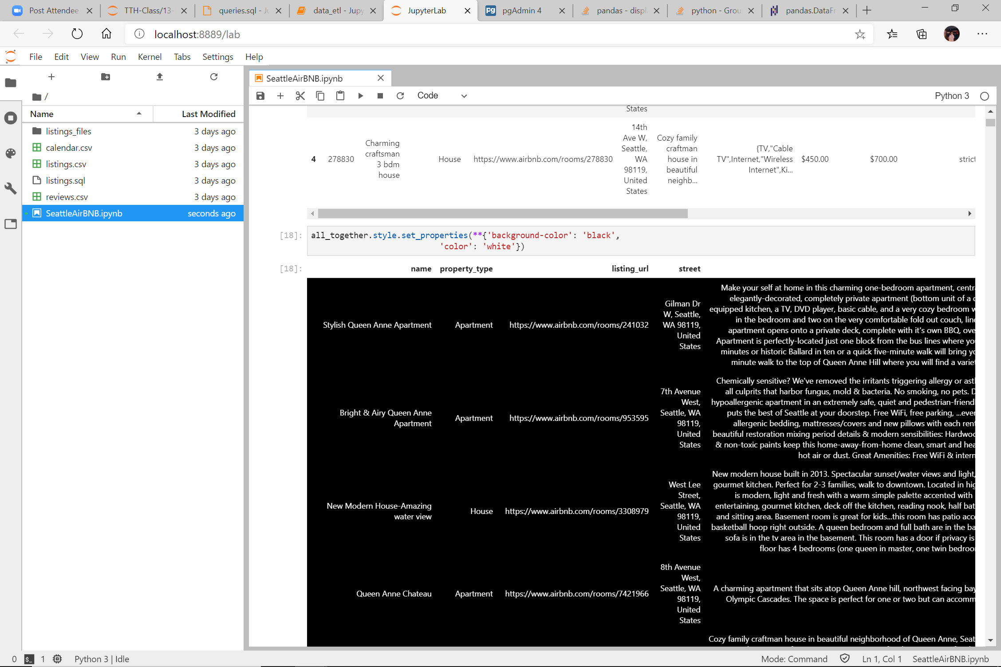

* 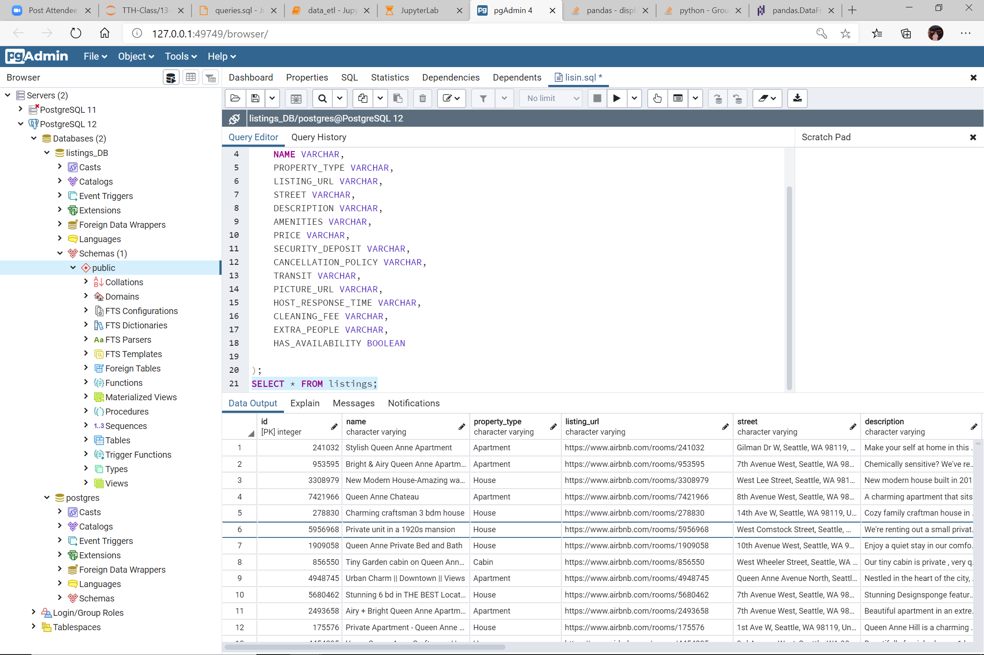And the results for it in Postgres for the same table:
* 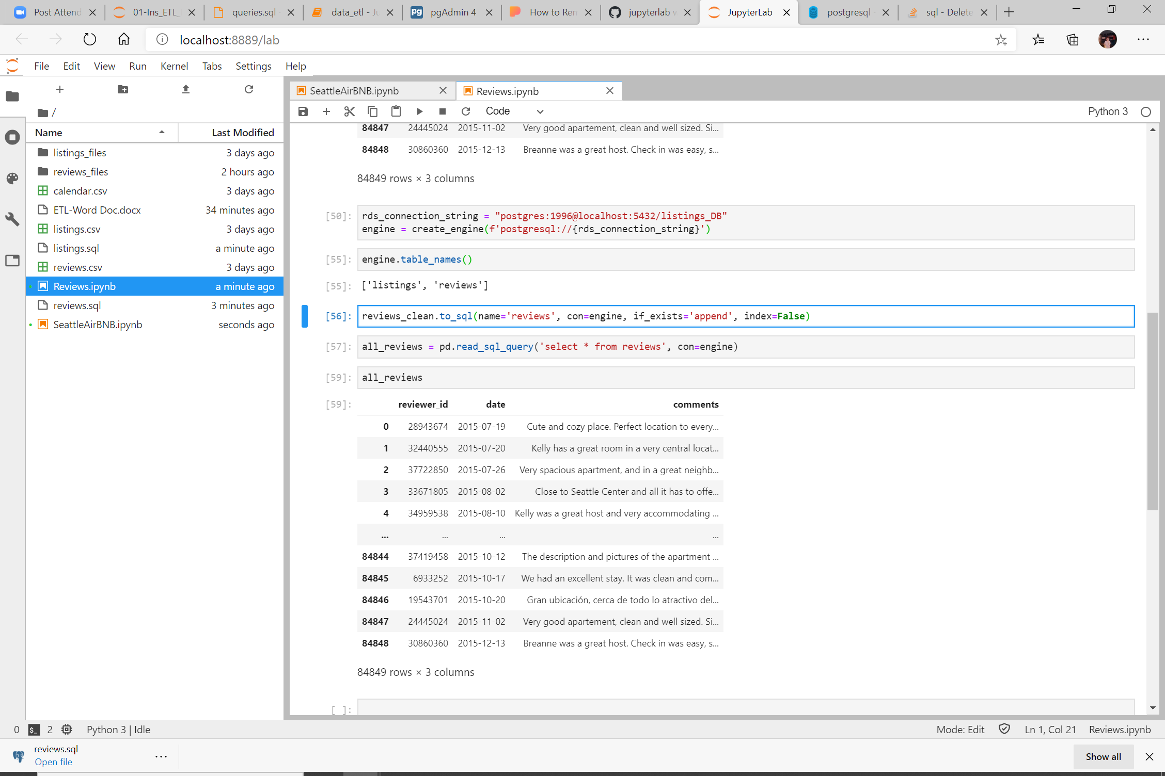Results for REVIEWS of the properties:
* Results in Postgres:

